Infra rood tachometer

Daan Joosten, Max Janissen, Pieter Vroegop

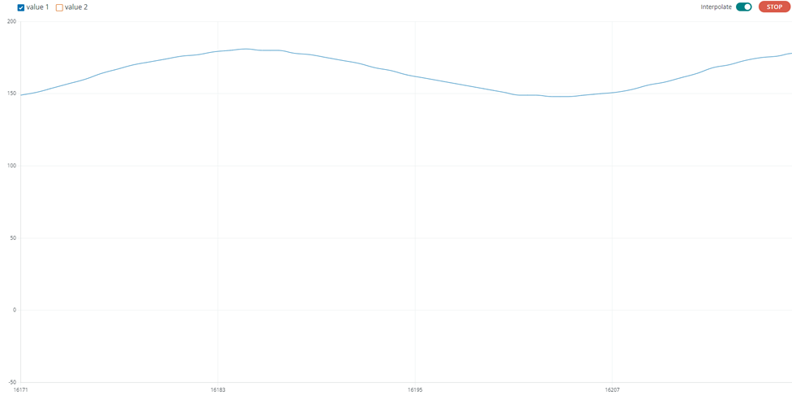

PWM signal

Toerental